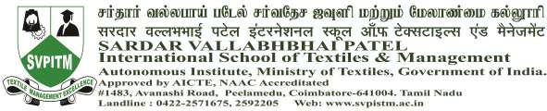

Summary Report

Hands-on Training Workshop on Statistical Application Analysis with SPSS
A one-day Hands-on Training Workshop on “Data Analysis using R Programming” was organized by the Department of Management for Business Analytics students of I Year BBA – Textile Business Analytics & I Year MBA- Textile Business Analytics on 26 May 2026 at CAD lab, Sardar Vallabhbhai Patel International School of Textiles & Management. The workshop was conducted from 10:30 AM to 4:30 PM with the objective of enhancing students with Analytical and programming skills through practical exposure to Statistical Application Analysis with SPSS.
The programme was coordinated by Ms Priyanka G, Assistant Professor, Business Analytics. The resource person for the workshop was Ms Praveena S, Pumo Techovation, Coimbatore, who has expertise in data analytics and programming applications.
The workshop focused on introducing students to the fundamentals of Statistical Application Analysis with SPSS and its applications in data analysis. The sessions covered topics such as introduction to SPSS, data importing techniques, data cleaning and pre-processing, basic statistical analysis, graphical representation of data, and interpretation of analytical results. The trainer demonstrated various commands and functions in SPSS with real-time examples, enabling students to gain practical understanding through hands-on exercises.
Students actively participated in the workshop and performed practical activities using Textile datasets during the session. The interactive nature of the training helped students understand the importance of data analysis in business decision-making and Textile industry applications. The programme also provided exposure to analytical tools that are relevant to the current industry requirements and academic curriculum.
A total of 28 students registered 22 for the workshop, and students attended the programme successfully. Attendance was recorded and maintained by the faculty co-ordinator. The students expressed positive opinions about the workshop and appreciated the practical learning experience, clarity of explanation, and real-time demonstrations provided by the resource person.
The workshop was highly informative and beneficial in improving the students’ knowledge of data analytics and programming concepts. It successfully created awareness about the role of SPSS in business analytics, research, and data-driven decision-making.

Photo Gallery
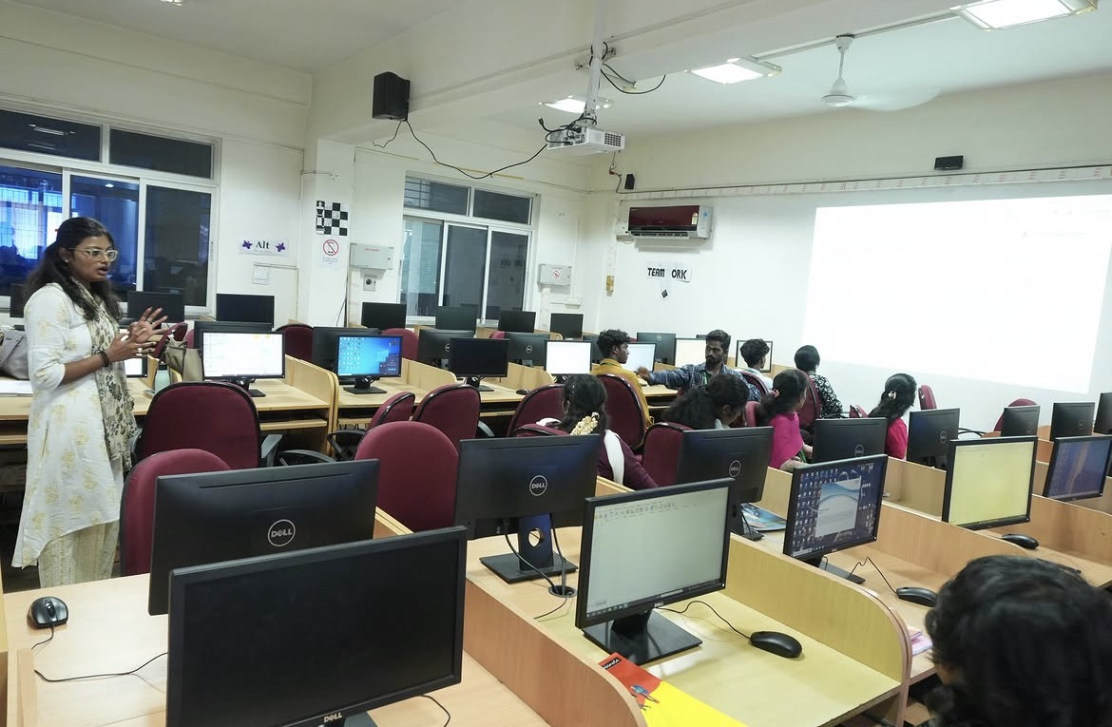
Resource person is delivering a lecture on Data analysis using SPSS programming.
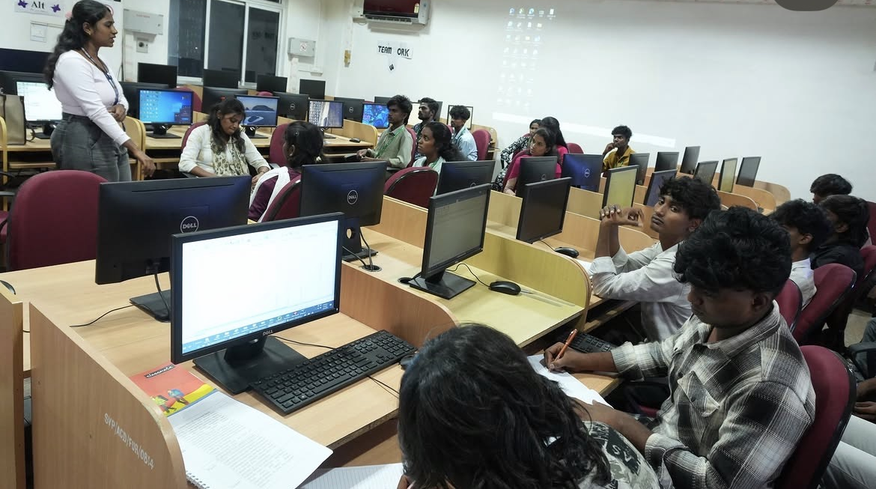Resource person providing hands-on guidance to students during the practical session on data analysis using SPSS Programming.

